SIMATS ENGINEERING (SAVEETHA SCHOOL OF ENGINEERING)

Department of Computer Science and Engineering

ASSESSMENT TOOL 1 – EXPERIMENTS

Course Code: | CSA0612 | Course Title: | Design and Analysis of Algorithms
CO Assessed: | CO3: Articulation  (BL4, BL5) | Assessment: | Assessment Tool 1 – Experiments
 |  | Total Marks: | 100
CO3 Statement: | Design Divide and Conquer algorithms for Merge Sort, Quick Sort, Binary Search and Matrix Multiplication
Student Name: | SRINIVASAN A | Reg. No.: | 192411025
Section / Batch: | 2024 | Date: | 04-08-2025
Instructions to Students
- Answer the following question. Total Marks: 100.
- Write the algorithm and execute the code for the given experiment.
- Follow a well-structured, systematic approach to design and implement an optimal solution.
- Provide insightful analysis with accurate validation, supported by clear documentation including diagrams, code, and results.

Question Type | Focus Area | Questions
Experiments | Design and Code for Divide and Conquer Algorithms: Merge Sort, Quick Sort, Binary Search, and Matrix Multiplication | Q1

SECTION A – Experiments

Q1. Evaluate Binary Search efficiency when applied to compressed or encoded datasets.Record execution time for decompression and search perations. Analyze overhead introduced by encoding. Interpret results and justify trade-offs between storage and search speed.
CodeofConduct
I SRINIVASAN A(192411025) (Name / Reg No) certify that this submission is my original work and that I have adheredtotheguidelinesspecifiedforthisassessment.Iunderstandthatanyviolationofacademicintegrityruleswill result in disciplinary action.
Signature of theStudent:SRINIVASAN A

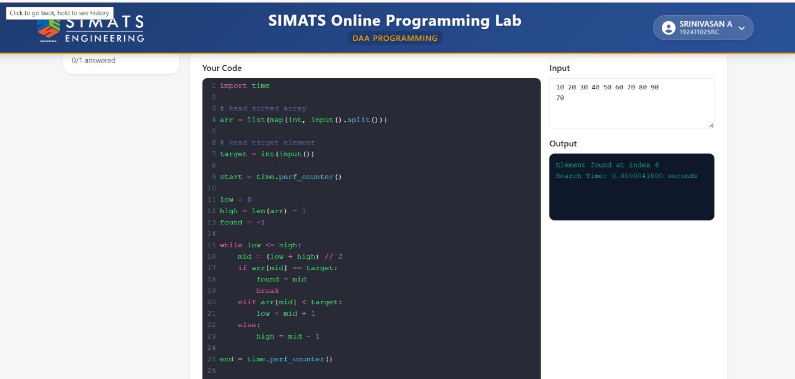

RUBRICS FOR CALCULATION

Experiments
Criteria | Weightage | Level 4 – Exemplary | Level 3 – Proficient | Level 2 – Developing | Level 1 – Beginning
Understa nding of Concepts | 25% | Demonstrates thorough understanding and effectively integrates multiple concepts/technologies | Good understanding with proper integration of most concepts | Basic understanding; limited or partial integration | Poor understanding  ; unable to integrate concepts
Experime ntal Design | 30% | Well-planned, systematic implementation with optimal solution | Correct implementatio n with minor issues | Basic implementation with errors or inefficiencies | Incorrect or incomplete implementatio n
Use of Tools | 20% | Effective and advanced use of tools/technologies with proper configuration | Appropriate use of tools with correct execution | Limited or inconsistent use of tools | Incorrect or minimal use of tools
Analysis of Results | 15% | Insightful analysis with accurate interpretation and validation of results | Good analysis with reasonable interpretation | Basic analysis with limited insights | Poor or incorrect analysis of results
Documen tation | 10% | Clear, well-structured documentation with diagrams, code, and  results | Organized documentation with necessary  details | Basic documentation with missing  details | Poor or incomplete documentatio  n

Marks Evaluation:
Criteria | Wt. | Level 4 – Exemplary | Level 3 – Proficient | Level 2 – Developing | Level 1 – Beginning
Understanding of Concepts | 25%
Experimental Design | 30%
Use of Tools | 20%
Analysis of Results | 15%
Documentation | 10%
Total Marks (100):

Faculty In-charge | Course Coordinator | Head of Department
Name: | Name: | Name:
Signature: | Signature: | Signature:
Date: | Date: | Date:

Algorithm: Binary Search with Execution Time

1. Start.
2. Read the sorted array from the user.
3. Read the target element to be searched.
4. Record the start time.
5. Set `low = 0` and `high = n - 1`.
6. Repeat while `low <= high`:
* Calculate `mid = (low + high) // 2`.
* If `arr[mid] == target`, display **"Element Found"** and its index, then stop the search.
* Else if `arr[mid] < target`, set `low = mid + 1`.
* Else, set `high = mid - 1`.
7. If the element is not found after the loop, display **"Element Not Found"**.
8. Record the end time.
9. Calculate the execution time as `end_time - start_time`.
10. Display the execution time.
11. Stop.

